Please use this video wherever makes sense to help youth get a sense of what joining a Q Chat Space discussion group will be like. For example, embed in your website alongside info about Q Chat Space, post on social media, etc.

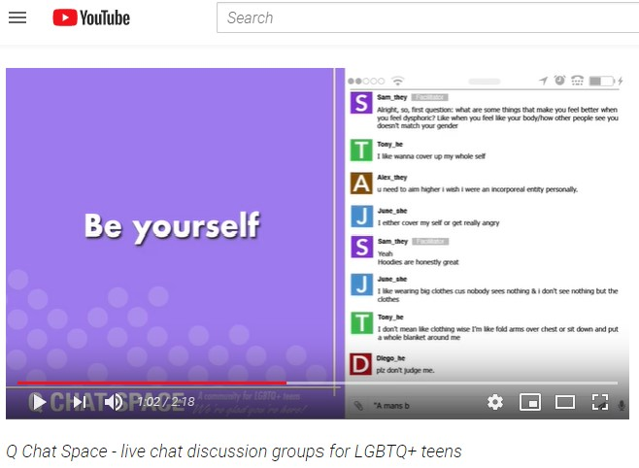
https://www.youtube.com/watch? v=8jY78nGhrKI&t=1s

